**Lab Task(s):**

**Exercise 1 (MYSQL Installation & Use of Command Line)**

1. Download and install MYSQL in your computer.

2. Import provided “hr.sql” database by using command line.

3. Connect imported database from command line.

**All done.**

**Exercise 2 (SELECT Statement):**

1. **Write a query to display the names (first_name, last_name) using the alias name “First Name", "Last Name".**

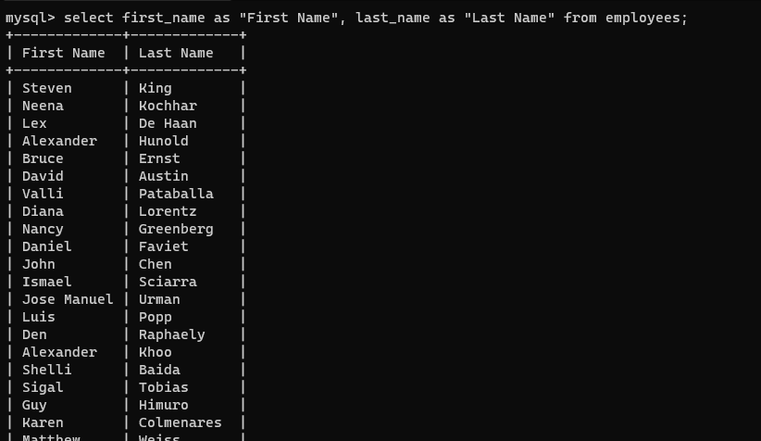

1. **Write a query to get a unique department ID from the employee table.**

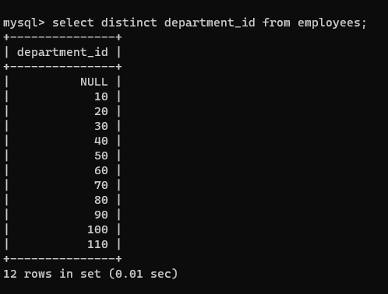

1. **Write a query to get all employee details from the employee table order by the first name, descending.**

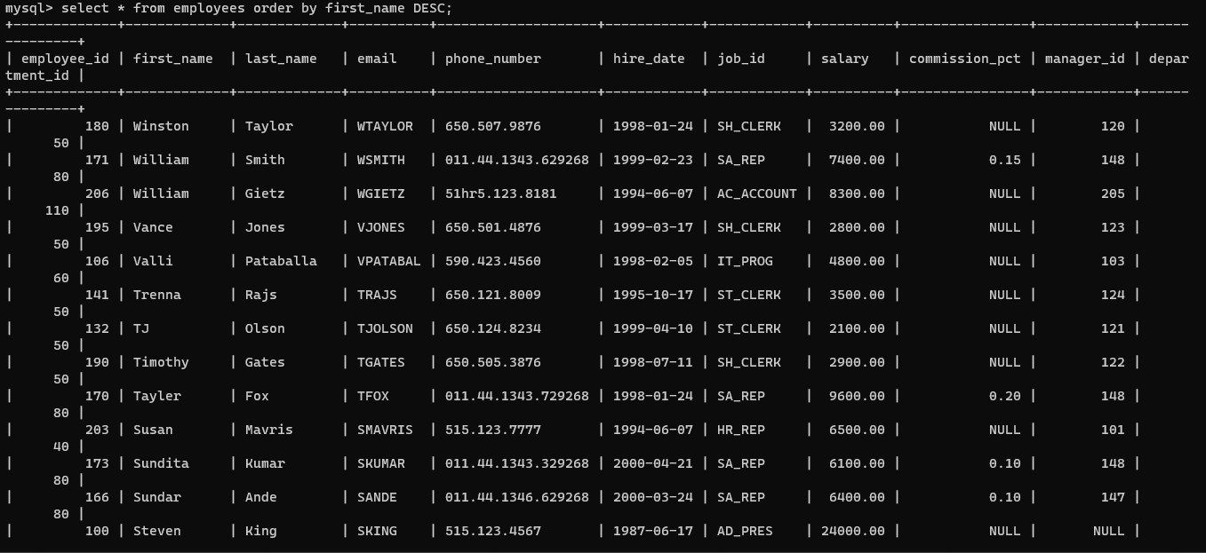

1. **Write a query to get the employee ID, names (first_name, last_name), salary in ascending order of salary.**

1. **Write a query to get the total salaries payable to employees.**

1. **Write a query to get the maximum and minimum salary from the employee's table.**

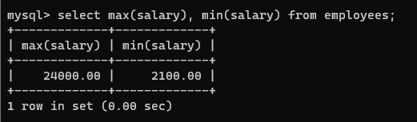

1. **Write a query to get the average salary and number of employees in the employees' table.**

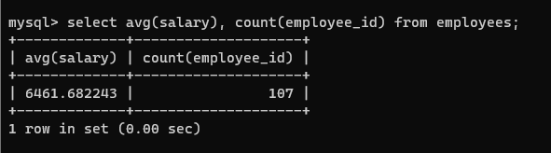

1. **Write a query to get the number of jobs available in the employee's table.**

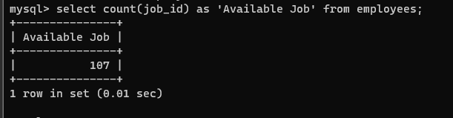

1. **Write a query to get all first names from the employee's table in the upper case.**

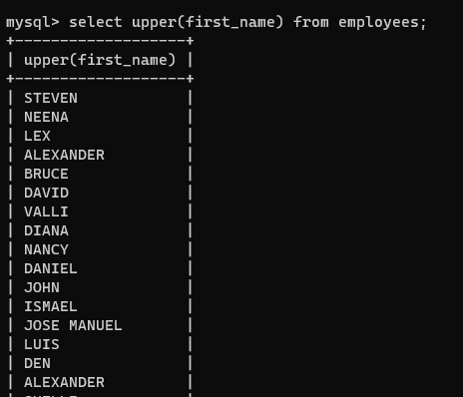

1. **Write a query to select the first 10 records from a table.**

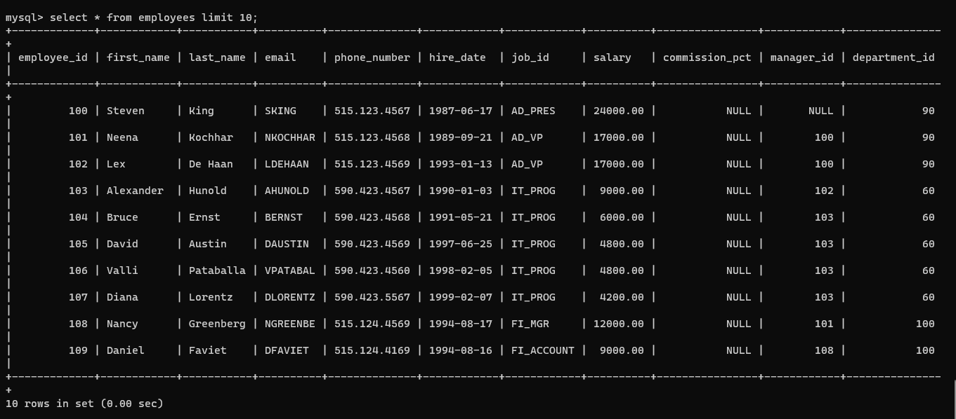

1. **Write a query to select the 3rd & 4th records of the employee's table.**

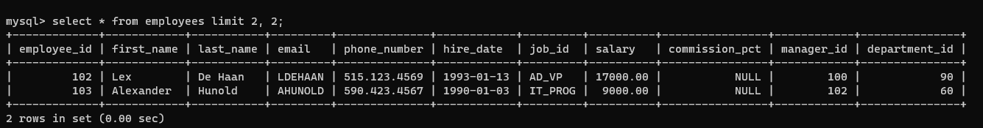

1. **Write a query to select 2nd last record of the employee's table.**

